INTRODUCTION
In today's digital age, the movie industry is rapidly evolving, and the need for a seamless and convenient movie ticketing and streaming system has become paramount. Our project aims to address the challenges faced by both movie enthusiasts and industry stakeholders by developing a comprehensive solution that streamlines the ticketing process and offers a user-friendly streaming platform. The rise of online streaming platforms has revolutionized the way people consume media content, providing them with the convenience of watching movies and shows from the comfort of their homes. However, the traditional movie theater experience still holds a special place for many moviegoers, and a seamless ticketing system is crucial for enhancing their overall experience. Our project seeks to bridge the gap between these two realms, offering a unified platform that caters to the diverse needs of movie enthusiasts, whether they prefer the big-screen experience or the convenience of streaming.
MEETING PLATFORMS
Effective collaboration and communication are crucial for the successful execution of this project. To facilitate seamless interactions among team members, we will leverage industry-standard meeting platforms such as Zoom and Microsoft Teams. These platforms will enable us to conduct virtual meetings, share screens, and collaborate in real-time, ensuring that all stakeholders are aligned and informed throughout the project's lifecycle.
VERSION CONTROL
Effective version control is essential for managing the codebase, tracking changes, and facilitating collaboration among the development team. For this project, we will be utilizing GitHub, a widely adopted and industry-leading version control platform.
PROJECT MANAGEMENT
Project management is crucial for ensuring that our movie ticketing and streaming system project stays on track, meets deadlines, and delivers the desired outcomes. To streamline our project management efforts, we will be utilizing Asana, a powerful and user-friendly project management tool.
Asana provides a centralized platform where we can organize and manage all project-related tasks, deadlines, and resources. We will create a dedicated workspace for our project, where team members can collaborate, assign tasks, and track progress seamlessly.

SYSTEM ANALYSIS AND DESIGN

SCENARIOS
Scenario 1: User Browsing and Booking a Movie
User: Alice
Alice wants to watch a movie this weekend. She uses the movie ticketing web app to browse and book a movie.
Steps:
- Open Web App: Alice opens the movie ticketing web app on her laptop.
- View Movies: On the homepage, she sees a list of currently showing movies. She clicks on a movie poster to see more details.
- Select Movie: She selects a movie that interests her and clicks on it to view more details, including the synopsis, cast, and ratings.
- Select Theater: She is presented with a list of theaters showing the selected movie. She chooses her preferred theater.
- Select Showtime: The web app displays the available showtimes for that theater. Alice selects a convenient time.
- Book Showtime: She proceeds to book the showtime by providing her contact details.
- Make Payment: The web app directs her to the payment page, where she enters her payment information and completes the transaction.
- Confirmation: Alice receives a booking confirmation on the web app, which she can also receive via email.
Scenario 2: User Checking Movie Details Before Deciding
User: Bob
Bob is deciding which movie to watch with his friends and wants to check movie details before making a decision.
Steps:
- Open Web App: Bob opens the movie ticketing web app on his phone.
- View Movies: He scrolls through the list of movies currently showing.
- Select Movie: Bob clicks on several movies to read their synopses, check ratings, and view trailers.
- Select Theater: For each movie, he checks which theaters are showing it and their locations.
- Select Showtime: He reviews the available showtimes for his preferred theaters but doesn’t make a booking yet.
- Decision Making: Bob shares the details with his friends and decides to book later. He closes the app.
Scenario 3: User Making a Quick Booking for a Nearby Theater
User: Carol
Carol has some free time in the evening and decides to catch a movie at a nearby theater.
Steps:
- Open Web App: Carol opens the movie ticketing web app on her tablet.
- View Movies: She quickly browses the movies showing that evening.
- Filter by Theater: Carol uses the filter feature to display movies at her nearby theater.
- Select Movie and Showtime: She selects a movie that starts soon and checks the available showtimes.
- Book Showtime: Carol selects a showtime and proceeds to the booking page.
- Make Payment: She enters her payment details and confirms the booking.
- Confirmation: Carol receives a booking confirmation on the web app and via SMS.

MOVIE TICKETING SYSTEM USE CASE
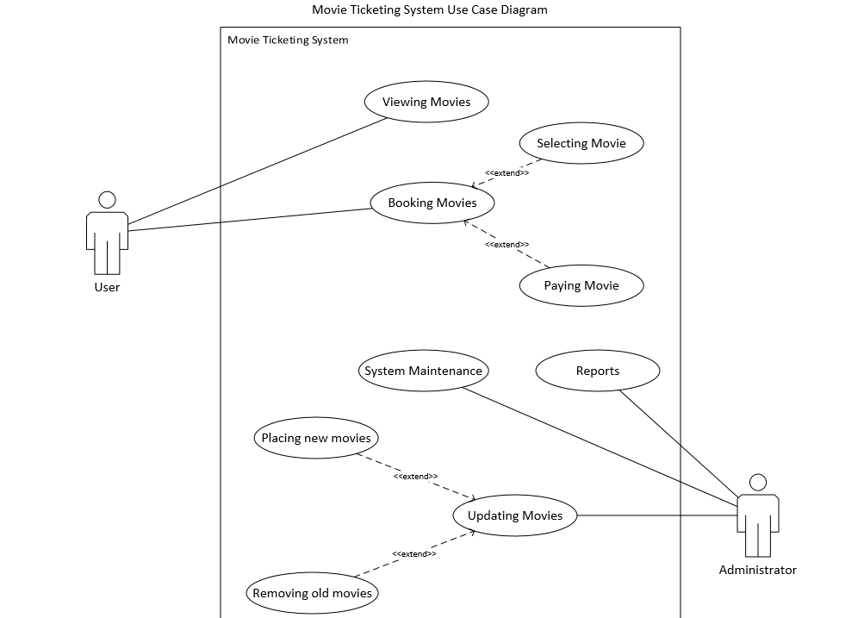
MOVIE TICKETING SYSTEM ENTITY RELATIONSHIP DIAGRAM
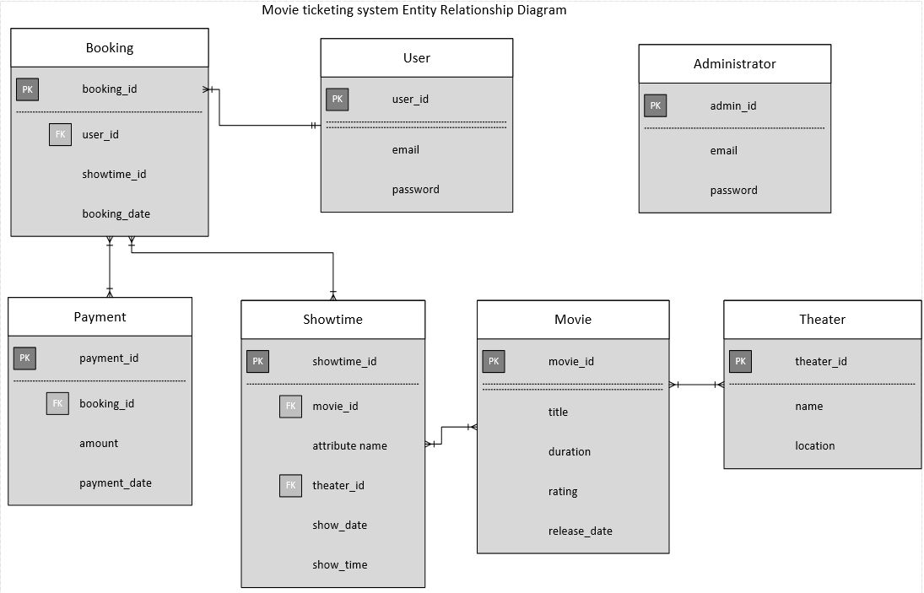
MOVIE TICKETING SYSTEM SEQUENCE DIAGRAM
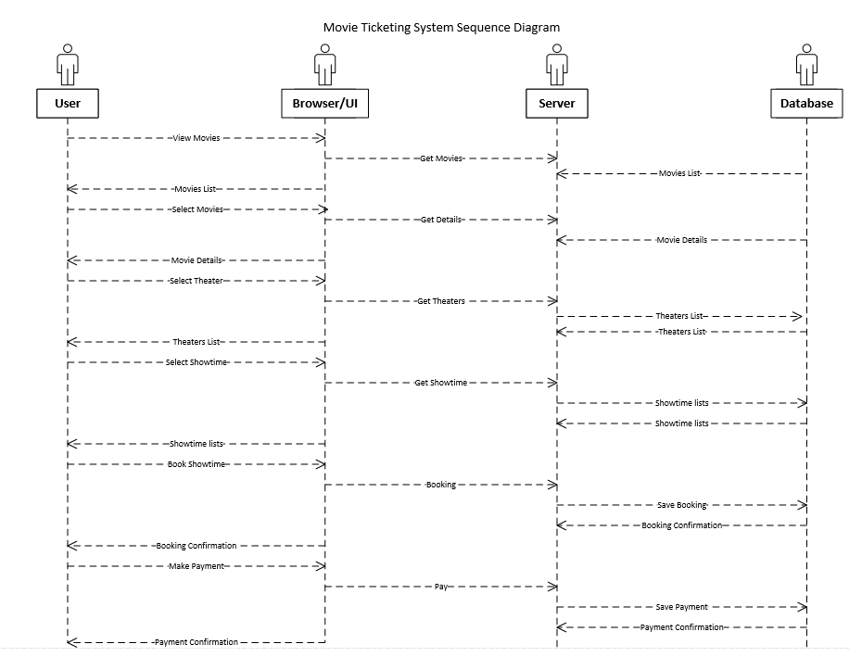

SYSTEM ARCHITECTURE DIAGRAM
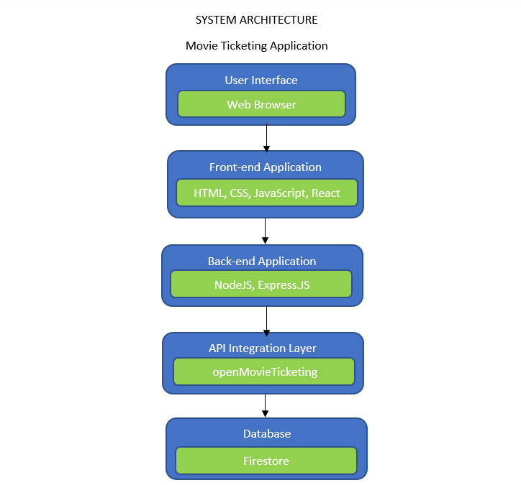
FUNCTIONAL AND NON-FUNCTIONAL REQUIREMENTS
FUNCTIONAL
- User registration and authentication - The system should allow users to create accounts, log in, and manage their profiles securely.
- Movie browsing and search - Users should be able to browse and search for movies based on various criteria, such as genre, release date, and rating.
- Ticket booking - The system should provide a user-friendly interface for users to select showtimes, choose seats (if applicable), and complete the ticket booking process seamlessly.
- Payment Integration: The system should support secure payment gateways, allowing users to purchase tickets and subscriptions using various payment methods.
- Streaming Functionality: Users should be able to stream movies on-demand, with features like pause, resume, and playback quality adjustment.
- User Reviews and Ratings: Users should be able to leave reviews and ratings for movies they have watched, contributing to the overall rating system and community engagement.
NON-FUNCTIONAL REQUIREMENTS
- Performance and Scalability: The system should be able to handle high traffic volumes and scale seamlessly to accommodate increasing user demand.
- Availability and Reliability: The system should be highly available and reliable, minimizing downtime and ensuring a consistent user experience.
- Security: The system should implement robust security measures to protect user data, payment information, and prevent unauthorized access or data breaches.
- Usability and User Experience: The user interface should be intuitive, responsive, and provide a seamless and enjoyable experience across various devices and platforms.
- Cross-Platform Compatibility: The system should be compatible with different operating system.

